Tatton Wildlife Newsletter – Summer
The warmer days of summer are a favourite time for many people and Tatton is a fantastic place to explore at this time of year. There is so much to see in this wonderful season and just getting out there and enjoying Tatton’s natural beauty will reap a variety of benefits.
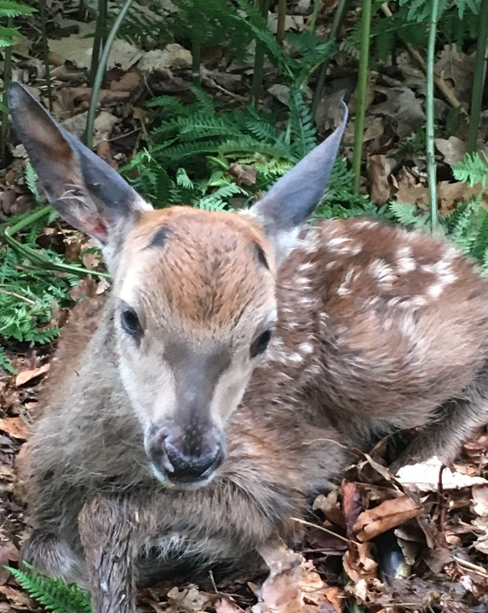
Deer
The deer now moult into their smart summer coats. The red deer change to the deep russet colour from where they derive their name and the fallow deer become speckled and brighter.
Antlers have now been cast by the male deer and they will spend the summer “in velvet” growing new ones. They are now soft to the touch and any knocks or damage to them may cause a deformity later in the rut when they are needed most. Because of this, any disputes at this time are settled by boxing, where the deer rear up on hind legs and box with their front.
Summer is also calving time. The females will drop the calf or fawn from a standing position near a fallen branch or clump of nettles and leave it. They will return when it is quieter to feed it and it is important that if you do find one in the park, you leave it alone and undisturbed.
Birds
Spring migration seemed slow to get going this year, with martins and swallows only arriving in small numbers, the first sand martin arriving on the 8^{th of} March. Notable sightings in April were a little gull and a whinchat with several sightings of wheatears passing through. Three common sandpipers and an arctic tern were seen in May. The heronry at Higmere has had 16 active nests which is a good count and we have had breeding ravens and kingfisher too already this year.
Things tend to settle down over summer, with birds getting on with the serious business of rearing young while there is a plentiful food supply, and hopefully better weather with more daylight hours to provide for them. Now is the best time to look out for black terns, hobbies or even ospreys, all of which have been seen here during the summer months in the past.
Flowers and Grasslands
The grassland at Tatton is carefully managed to provide a variety of sward lengths which encourages a rich biodiversity of flora and fauna. Longer grass is good habitat for voles which are, in turn, a food source for kestrels and barn owls. They also host a wide variety of insects. The shorter grass allows certain types of fungi to grow some of which are the waxcap species. Summer is the best season to enjoy wildflowers in the parkland such as harebells, tormentil, and speedwell. The edges of the meres are home to skullcap, loosestrife, and yellow flag iris. These flowers allow butterflies and other insects to thrive.
Bats
Summer is an important time for Britain’s bats. The females mated in the autumn and through the process of delayed implantation will be ready to give birth in June and July. At this time, females gather in maternity roosts to raise their young which are called pups. Tatton has known roosts in the Old Hall, one end is used by soprano pipistrelles (over two hundred have been counted in previous summers) whilst the Great Hall is occupied by a colony of brown long eared bats with a smaller roost of around fifty. Males take no part in rearing the pups and will roost either alone or in small groups, building up strength and condition for the whole process to start again in autumn.

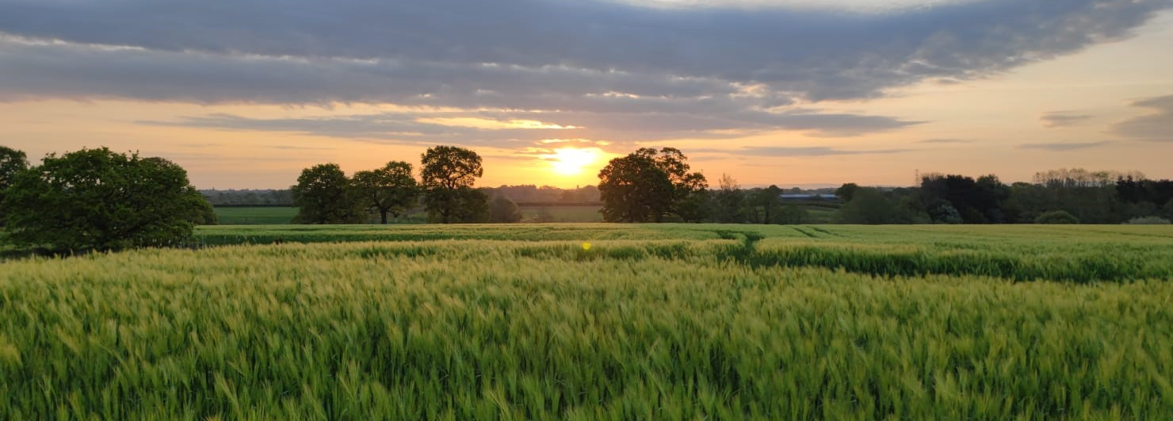

Compiled by Tatton’s Ranger Team

